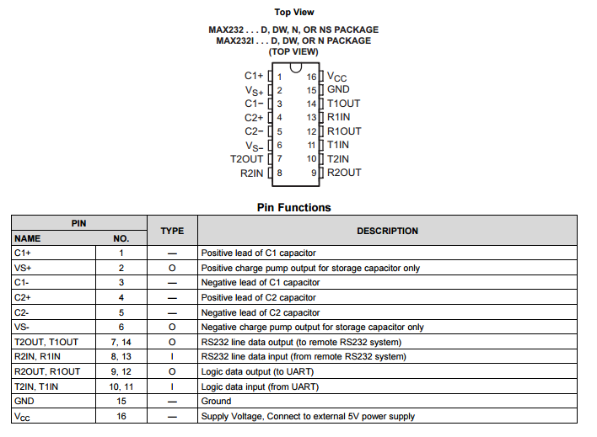

Figure 1. MAX232 Datasheet

# **MAX232 Circuits:**

Style 1:

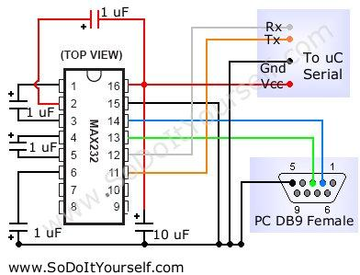

Style 2:

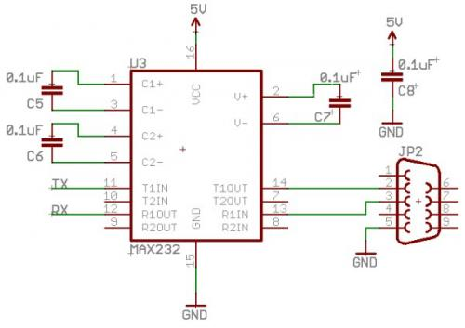

Style 3:

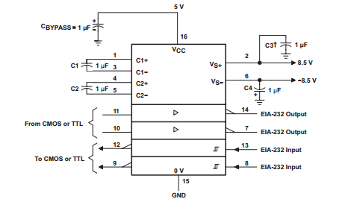

Style 4: with Arduino

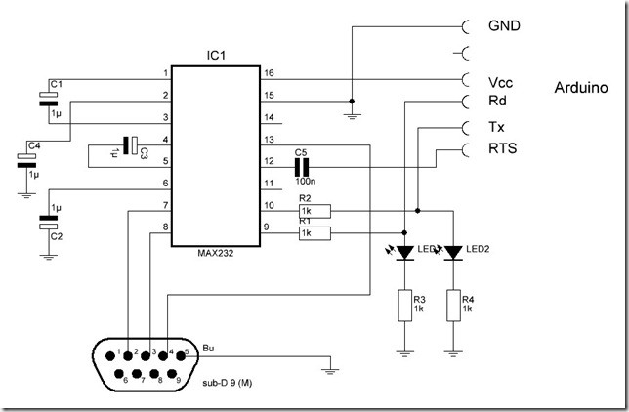

Whole article address:

<https://arduinodiy.wordpress.com/2012/03/19/serial-connection-for-your-arduino-atmega/>